Student Performance Prediction System

Project Id: PY-PT57

Name : Paras Goel (Team Leader)
Class Roll Number: 57
University Roll Number : 2028790
Section and Group: P (G2)

Name : Pratyaya Amrit Raj
Class Roll Number : 58
University Roll Number : 2028805
Section and Group : P (G2)

Name : Ujjwal Singh Rohilla
Class Roll Number : 76
University Roll Number : 2028894
Section and Group : P (G2)

TABLE OF CONTENTS
- Problem Description 3
  - Dataset Description 3
  - Flow diagram 4
- Modules for Project Implementation…………………..…………………………5
  - Modules Used 5
  - Platform Used 6
- Machine Learning model/ Searching Technique used 7
- Evaluation metrics used 8
- Results and Visualizations 9
- Conclusion and Future Scope 11
- References 12

- Problem Description
The aim of this project is to develop a machine learning-based system that can predict whether a patient is likely to have a disease based on clinical data. Early prediction of diseases helps in timely treatment and reduces health risks.
In this phase, we implemented machine learning models on the preprocessed dataset to classify patients into two categories: disease and no disease. The system uses various health parameters such as age, BMI, blood pressure, glucose, cholesterol, smoking habits, physical activity, and family history.
The project focuses on building an efficient classification system using multiple algorithms and evaluating their performance.

1.1 Dataset Description

The dataset used contains patient health records. Each row represents a patient and each column represents a feature.

Features:
- Age
- Gender
- BMI
- Blood Pressure
- Glucose
- Cholesterol
- Smoking
- Physical Activity
- Family History

Target:
- Disease (0 = No Disease, 1 = Disease)
The dataset is slightly imbalanced, with more disease cases than non-disease cases.

  - Flow Diagram

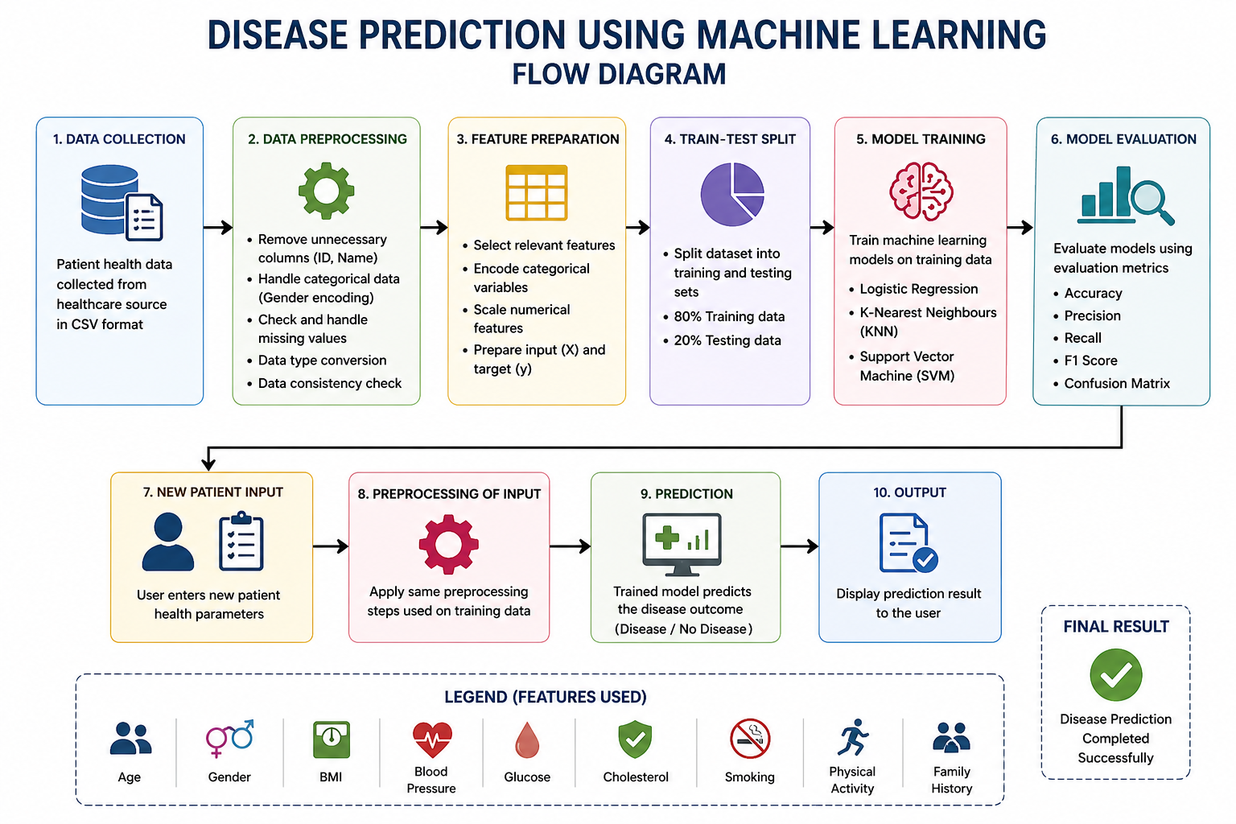

This flow diagram represents the overall working of the disease prediction system. It starts with data collection and preprocessing, followed by feature preparation and model training. Finally, the trained model is used to predict whether a patient has a disease based on input data.

2. Modules for Project Implementation

2.1 Modules Used(mention all the inbuilt/ custom modules used and the purpose)

1. Pandas

Used for data manipulation and analysis.
Functions used:

pd.read_csv() – to load dataset

.head() – to display data

.drop() – to remove columns

2. NumPy
Used for numerical operations.

3. Matplotlib

Used for plotting graphs such as accuracy comparison and ROC curve

4. Scikit-learn
Used for machine learning models.
Functions used:
- train_test_split() – splitting data
- StandardScaler() – feature scaling
- LogisticRegression()
- KNeighborsClassifier()
- SVC()

5. Seaborn
Used for confusion matrix visualization.

2.2 Platform Used: (mention all the platforms with the reason of using it)

- Jupyter Notebook
Used for coding, testing, and visualization of results.

- Python
Used as the programming language due to its simplicity and powerful libraries.

3. Machine Learning Model/ Searching Technique Used(Describe each ML model/ searching technique used)

In this project, three supervised machine learning algorithms were used to predict whether a patient has a disease or not. These models learn patterns from the training data and classify new data into two categories: disease (1) and no disease (0). The models used are Logistic Regression, K-Nearest Neighbours (KNN), and Support Vector Machine (SVM).

- Logistic Regression
Logistic Regression is used for binary classification problems. It calculates the probability of a patient having a disease using a sigmoid function and then classifies the result into 0 or 1. It is simple, fast, and easy to understand.

- KNN
K-Nearest Neighbours (KNN) works by comparing a new data point with its nearest neighbors. It finds the K closest data points and assigns the class based on majority voting. It is simple and works well when similar data points are close to each other.

- SVM
Support Vector Machine (SVM) works by finding the best boundary (hyperplane) that separates the data into different classes. It is effective for handling complex datasets and often provides better accuracy compared to simpler models.

These models were trained and tested on the dataset, and their performance was compared to select the most suitable model for disease prediction.

4. Evaluation metrics used (Describe each evaluation metric used along with formulae)

1. Accuracy
Accuracy measures the overall correctness of the model. It shows how many predictions were correct out of the total predictions made.
Formula:
Accuracy = (TP + TN) / (TP + TN + FP + FN)

2. Precision
Precision measures how many of the predicted positive cases are actually correct. It focuses on the quality of positive predictions.
Formula:
Precision = TP / (TP + FP)

3. Recall
Recall measures how many actual positive cases are correctly identified by the model. It shows how well the model detects positive cases.
Formula:
Recall = TP / (TP + FN)

4. F1 Score
F1 Score is the harmonic mean of precision and recall. It provides a balance between both and is useful when the dataset is imbalanced.
Formula:
F1 Score = 2 × (Precision × Recall) / (Precision + Recall)

5. Confusion Matrix
A confusion matrix is a table used to evaluate the performance of a classification model. It shows the number of correct and incorrect predictions.
- TP (True Positive): Correctly predicted disease cases
- TN (True Negative): Correctly predicted non-disease cases
- FP (False Positive): Incorrectly predicted disease
- FN (False Negative): Missed disease case
- 5. Results and Visualizations

The models were trained and evaluated on test data.

Observations:

- Logistic Regression performed well for simple patterns
- KNN worked based on neighbor similarity
- SVM showed better performance compared to others

Graphs included:

- Accuracy comparison bar graph
- ROC Curve
- Confusion Matrix

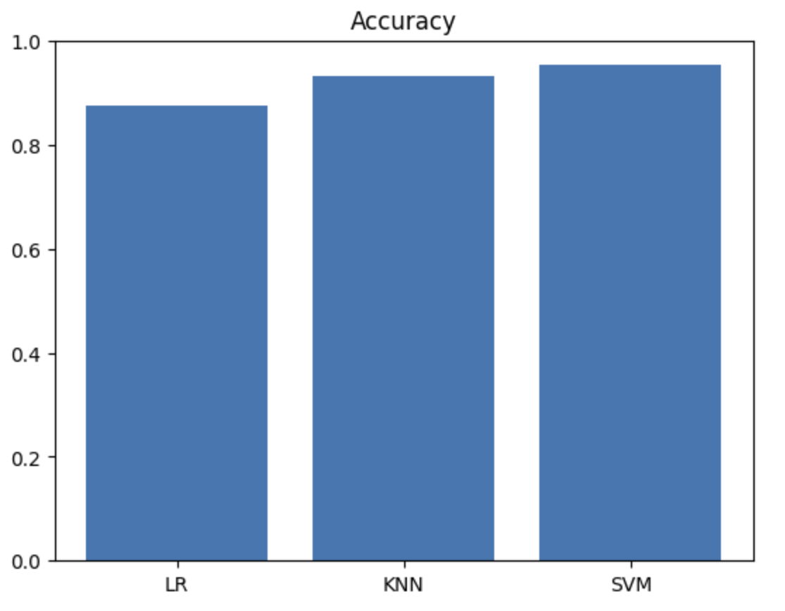

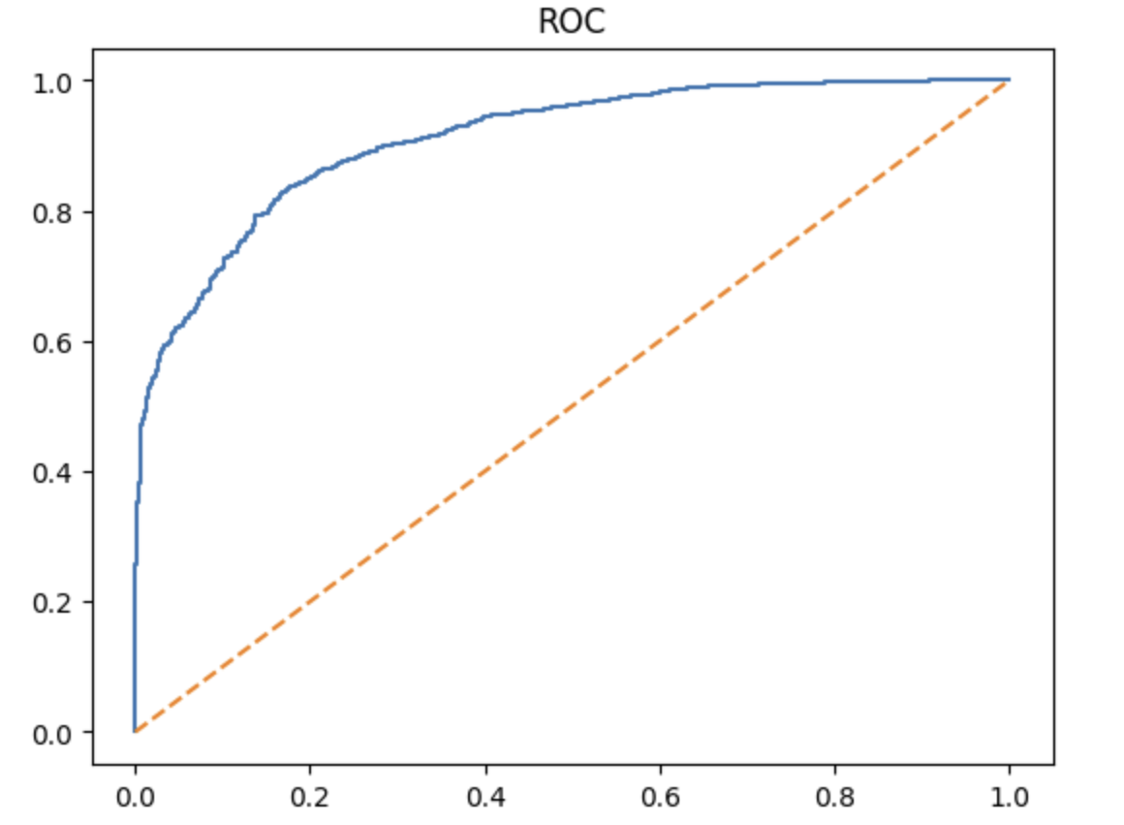

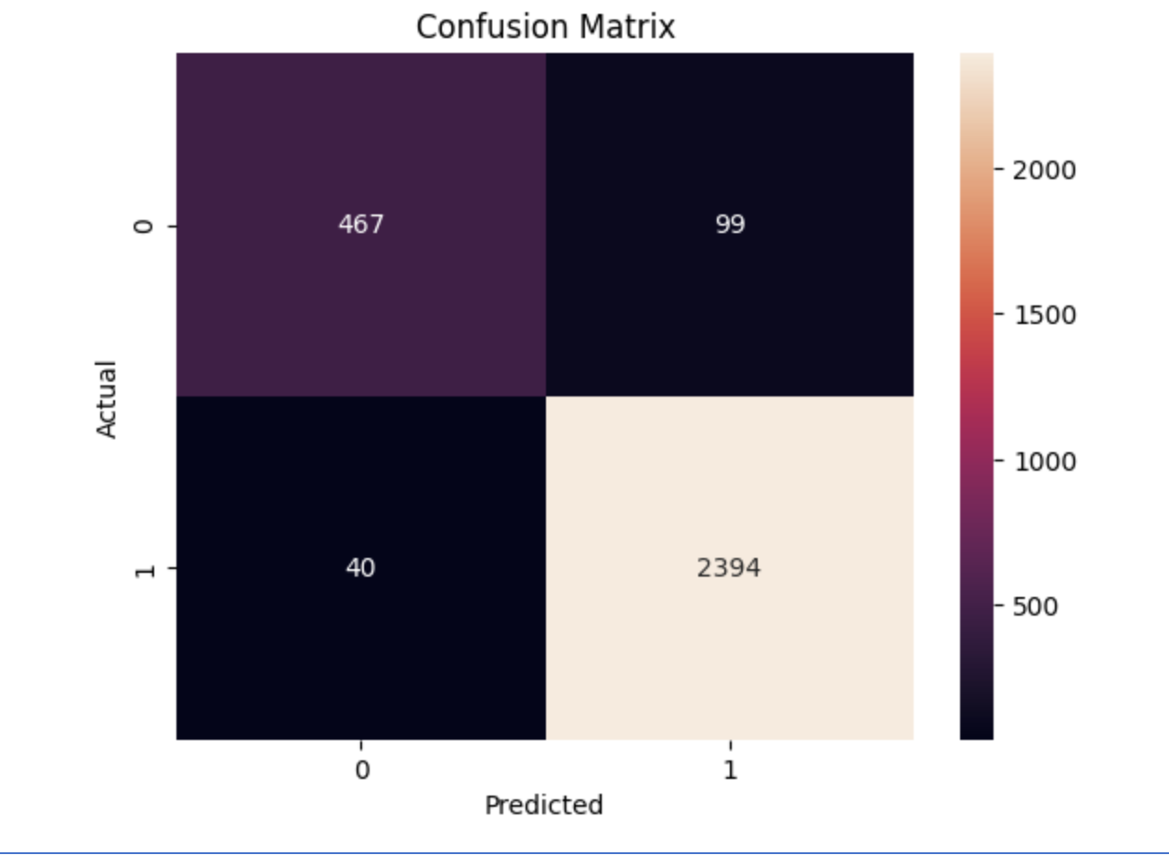
6. Conclusion and Future Scope:

- Conclusion

In this project, we successfully developed a machine learning-based system for disease prediction using patient health data. The dataset was preprocessed and various machine learning models such as Logistic Regression, K-Nearest Neighbours (KNN), and Support Vector Machine (SVM) were applied. The models were trained and evaluated using different metrics like accuracy, precision, recall, and F1 score.
From the results, it was observed that different models perform differently based on the dataset. Among them, SVM showed comparatively better performance in predicting disease. This project demonstrates how machine learning can be effectively used in the healthcare domain to assist in early disease detection and decision-making.

- Future Scope

In the future, the project can be improved in several ways. More advanced machine learning algorithms and deep learning techniques can be used to improve prediction accuracy. The dataset can be expanded with real-world medical data for better performance. Techniques to handle data imbalance can also be applied.
Additionally, a user-friendly interface such as a web or mobile application can be developed so that users can easily input their health details and get predictions. This system can also be integrated with healthcare systems to support doctors in making better decisions.

7. References:
Books:
- Let Us Python – Yashavant Kanetkar

Online Resources:
  - GeeksforGeeks – https://www.geeksforgeeks.org/
  - TutorialsPoint – https://www.tutorialspoint.com/cprogramming/index.htm
  - Stack Overflow – https://stackoverflow.com

